Always show all work for full credit.

Binary | Decimal | Hex
1110100
 |  | 0x1CA
 | 268
  - Review: Fill in the missing values in the following table (all values are unsigned)
  - Write a Boolean equation in sum-of-products canonical form for:
A | B | C | Y
0 | 0 | 0 | 1
0 | 0 | 1 | 1
0 | 1 | 0 | 0
0 | 1 | 1 | 0
1 | 0 | 0 | 1
1 | 0 | 1 | 0
1 | 1 | 0 | 0
1 | 1 | 1 | 1

  - Write a Boolean equation in sum-of-products canonical form for:
A | B | C | D | Y
0 | 0 | 0 | 0 | 1
0 | 0 | 0 | 1 | 1
0 | 0 | 1 | 0 | 0
0 | 0 | 1 | 1 | 0
0 | 1 | 0 | 0 | 1
0 | 1 | 0 | 1 | 0
0 | 1 | 1 | 0 | 0
0 | 1 | 1 | 1 | 1
1 | 0 | 0 | 0 | 0
1 | 0 | 0 | 1 | 0
1 | 0 | 1 | 0 | 1
1 | 0 | 1 | 1 | 0
1 | 1 | 0 | 0 | 1
1 | 1 | 0 | 1 | 1
1 | 1 | 1 | 0 | 0
1 | 1 | 1 | 1 | 1

  - Write a Boolean equation in sum-of-products canonical form for:
A | B | C | Y
0 | 0 | 0 | 0
0 | 0 | 1 | 1
0 | 1 | 0 | 0
0 | 1 | 1 | 1
1 | 0 | 0 | 0
1 | 0 | 1 | 0
1 | 1 | 0 | 1
1 | 1 | 1 | 1

  - Write a Boolean equation in sum-of-products canonical form for:
A | B | C | D | Y
0 | 0 | 0 | 0 | 1
0 | 0 | 0 | 1 | 1
0 | 0 | 1 | 0 | 1
0 | 0 | 1 | 1 | 1
0 | 1 | 0 | 0 | 0
0 | 1 | 0 | 1 | 1
0 | 1 | 1 | 0 | 1
0 | 1 | 1 | 1 | 0
1 | 0 | 0 | 0 | 1
1 | 0 | 0 | 1 | 0
1 | 0 | 1 | 0 | 1
1 | 0 | 1 | 1 | 0
1 | 1 | 0 | 0 | 0
1 | 1 | 0 | 1 | 0
1 | 1 | 1 | 0 | 1
1 | 1 | 1 | 1 | 0

  - Implement the below with only NAND gates (it’s the same function in 5). Sketch the circuit or use JLS to create the circuit diagram:
A | B | C | D | Y
0 | 0 | 0 | 0 | 1
0 | 0 | 0 | 1 | 1
0 | 0 | 1 | 0 | 1
0 | 0 | 1 | 1 | 1
0 | 1 | 0 | 0 | 0
0 | 1 | 0 | 1 | 1
0 | 1 | 1 | 0 | 1
0 | 1 | 1 | 1 | 0
1 | 0 | 0 | 0 | 1
1 | 0 | 0 | 1 | 0
1 | 0 | 1 | 0 | 1
1 | 0 | 1 | 1 | 0
1 | 1 | 0 | 0 | 0
1 | 1 | 0 | 1 | 0
1 | 1 | 1 | 0 | 1
1 | 1 | 1 | 1 | 0

  - Write the Boolean equations for the circuit below (no need to minimize: give the exact equations implemented in the circuit):

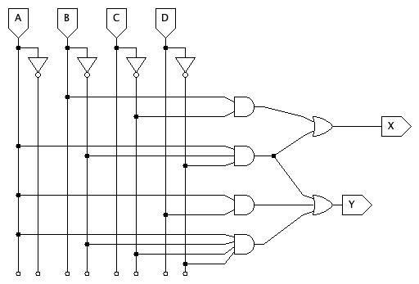

For the next four problems assume the propagation delays are:
Gate | $t_{pd}$ (ps)
NOT | 15
2-input NAND | 20
3-input NAND | 30
4-input NAND | 45
2-input NOR | 30
3-input NOR | 45
2-input AND | 30
3-input AND | 40
4-input AND | 50
2-input OR | 40
3-input OR | 55
4-input OR | 70
2-input XOR | 60

  - Determine the propagation delay of:
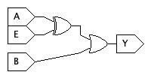
  - Determine the propagation delay of:
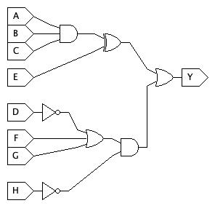
  - Determine the propagation delay of:
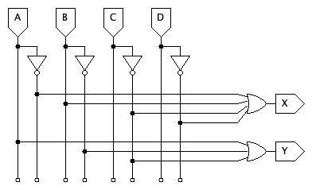
  - ERROR: No problem 11 (is/was redundant with 9; Now removed)

12.1 Consider adding 2-digit binary numbers, A and B, to produce the 2-bit result, S, and a carry-out, C:

$$\begin{matrix} & A_{1} & A_{0} \\ + & B_{1} & B_{0} \\ C & S_{1} & S_{0}\end{matrix}$$

Develop the truth table and sum-of-products equations for adding the two, 2-bit numbers and produce the 3-bits of the result.

12.2 Download the JLS starter file from the assignment page and complete the circuit. Note that it uses 2-bit inputs for A and B. You test all possible combinations of inputs to confirm your 2-bit adder works correctly.
Hints:
- Think carefully about the structure of the truth table and the terms being used for each output.
- Some product terms can be reused for different outputs.
- JLS has parts called “named wires”. Named wires can be used to organize your work and re-use common terms. Named wires have two parts: the source (“name a wire” is shown when you hover over the named wire part on the menu) and connections (“connect to a named wire”). You can use more than one of the “connect to a named wire” part to have a single wire connect multiple places without having a literal wire (line) running across the diagram. If you use named wires, try to name them with a name that describes their purpose.
- Some wires and parts have already been provided. They are intended to provide one tidy approach to laying out the circuit.
- This circuit uses multi-bit inputs and separates them into their individual bits (A0, A1, etc.) for you. Test signal values can be specified in decimal rather than binary. For example, A can be 0, 1, 2, or 3. When A is 2 its individual bits, A1 and A0, are 1 and 0 respectively. The bits of S are combined into a single, 2-bit output, which doesn’t include C.
- Carefully think about test cases. A signal generator has already been provided.
- DO NOT change the names of either input or output ports. The Autograder depends on them being named as-is.

13. JLS problem: See assignment page and use the provided starter file!

